Excellent Coaching

|  |  |  |
| --- | --- | --- |
| **Supervisor.** | **Miss Esha Shahid** | |
| **Batch.** | 2507G1 | |
| **Group.** | **D** | |
| **Serial No.** | **Enrollment Number** | **Student Name** |
| 1. | Student 1673177 | M.HASSAN ALI |
| 2. | Student 1674315 | ARQUM AHMED |
| 3. | Student 1674355 | M.USMAN |
| 4. | Student 1674431 | M.NEHAL |

**ACKNOWLEDGEMENT**

In this section, we would like to express our sincere gratitude to all those who guided and supported us during the preparation of this project.

* First of all, we would like to thank **Miss ESHA** for reviewing our project and guiding us within the limited time frame.
* We are also thankful to the **Aptech EProject Team** for giving us the valuable opportunity to work on this wonderful project titled *“Nexus Aquarium.”*
* Lastly, we are grateful for the learning experience we gained through this project, which helped us **enhance our practical skills**, **improve our confidence**, and **prepare**
* **ourselves better for future professional interviews.**
* ***SYNOPSIS***

This section provides a brief overview of the project:

* The website will provide students with the facility to **register online for different courses** offered by Excellent Coaching Centre.
* It will include **details about each course**, such as subjects, duration, fees, and schedules.
* A **faculty section** will highlight the profiles and qualifications of the teachers to build trust and credibility.
* A **location map** will be provided to help students and parents easily reach the coaching center.
* The website will feature a **modern, user-friendly, and educational design** to provide a professional and engaging experience for students.

***PROBLEM DEFINITION***

Excellent Coaching Centre is a well-known educational institute that provides quality coaching to students of different academic levels. The institute offers classes for **Matriculation, Intermediate, and Entry Test preparations**, along with other academic support programs.

Many students and parents face difficulty in getting updated information about **courses, timings, and admission procedures**. Currently, most communication is done manually, which takes time and effort.

To overcome these issues, the organization wishes to develop a **professional and responsive website** for Excellent Coaching Centre. The website will allow students to **view available courses, check schedules, learn about faculty members, and register online**.

***CUSTOMER REQUIREMENT***

***SPECIFICATION (CRS)***

The website for *Excellent Coaching Centre* will be created based on the following requirements:

1. The **Home Page** must include a well-designed **logo** and a welcoming **banner image** representing education and learning.
2. The website should include links such as **Home**, **Courses**, **Faculty**, **Gallery**, **About Us**, and **Contact Us**.
3. The **class timings** and **location** of the coaching center must be clearly mentioned.
4. A section for **upcoming events, workshops, or test schedules** (especially for students) should be provided with proper details.
5. An **online registration or sign-up page** (dummy form with validation) should be available for students who wish to enroll.
6. The **gallery section** should display images of classrooms, faculty, and student activities.
7. The **navigation** throughout the website should be smooth and easy to use.
8. The **color combination** should be **professional, bright, and uniform** across all pages.
9. A **course details table** should display information about the different subjects, levels, and fees.
10. A **feedback form (dummy)** should be provided for students and parents to share their opinions or suggestions.

***SCOPE OF THE WORK (IN BRIEF)***

The website for Excellent Coaching Centre will be developed using **HTML5**, **JavaScript**, **Bootstrap**, and **jQuery** to ensure a modern and responsive design.

The site will be **compatible with all major browsers**, including **Google Chrome, Mozilla Firefox, Microsoft Edge, and Safari**, providing a smooth experience for all users.

The website will be **fully responsive**, meaning it will display correctly and function efficiently on **desktop computers, tablets, and mobile devices**.

Each section of the website will be properly linked so that **every button or navigation item redirects to the correct content or page**, ensuring easy access to information such as courses, faculty, events, and registration forms.

The overall goal is to create a **user-friendly, attractive, and professional educational website** that enhances the reputation and digital presence of Excellent Coaching Centre.

***AGGREGATED SITEMAP***

HOME

COURSES

FACULTY

WHY CHOOSE US

SUCCESS STORIES

BRANCHES

CONTACT US

ENROOL NOW

***Screenshots***

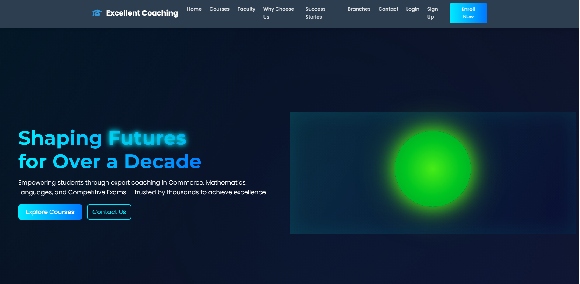

**GENERAL INFORMATION:**  


**OUR COURSES:**  
  
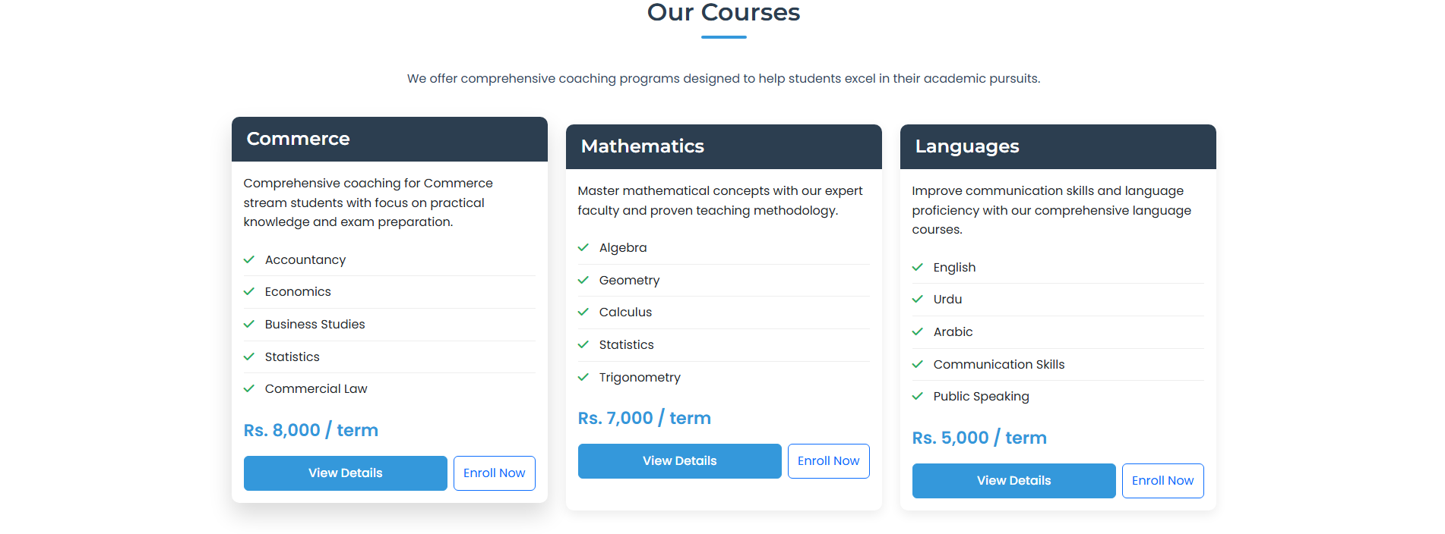

**WHY CHOOSE US:**  
  
  
  
**OUR FACULTY:**  
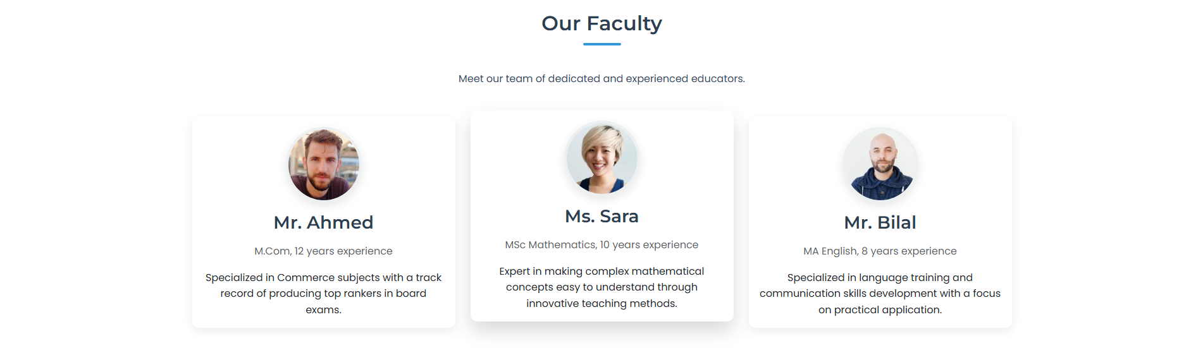

**SUCCESS STORIES:**  
  
  
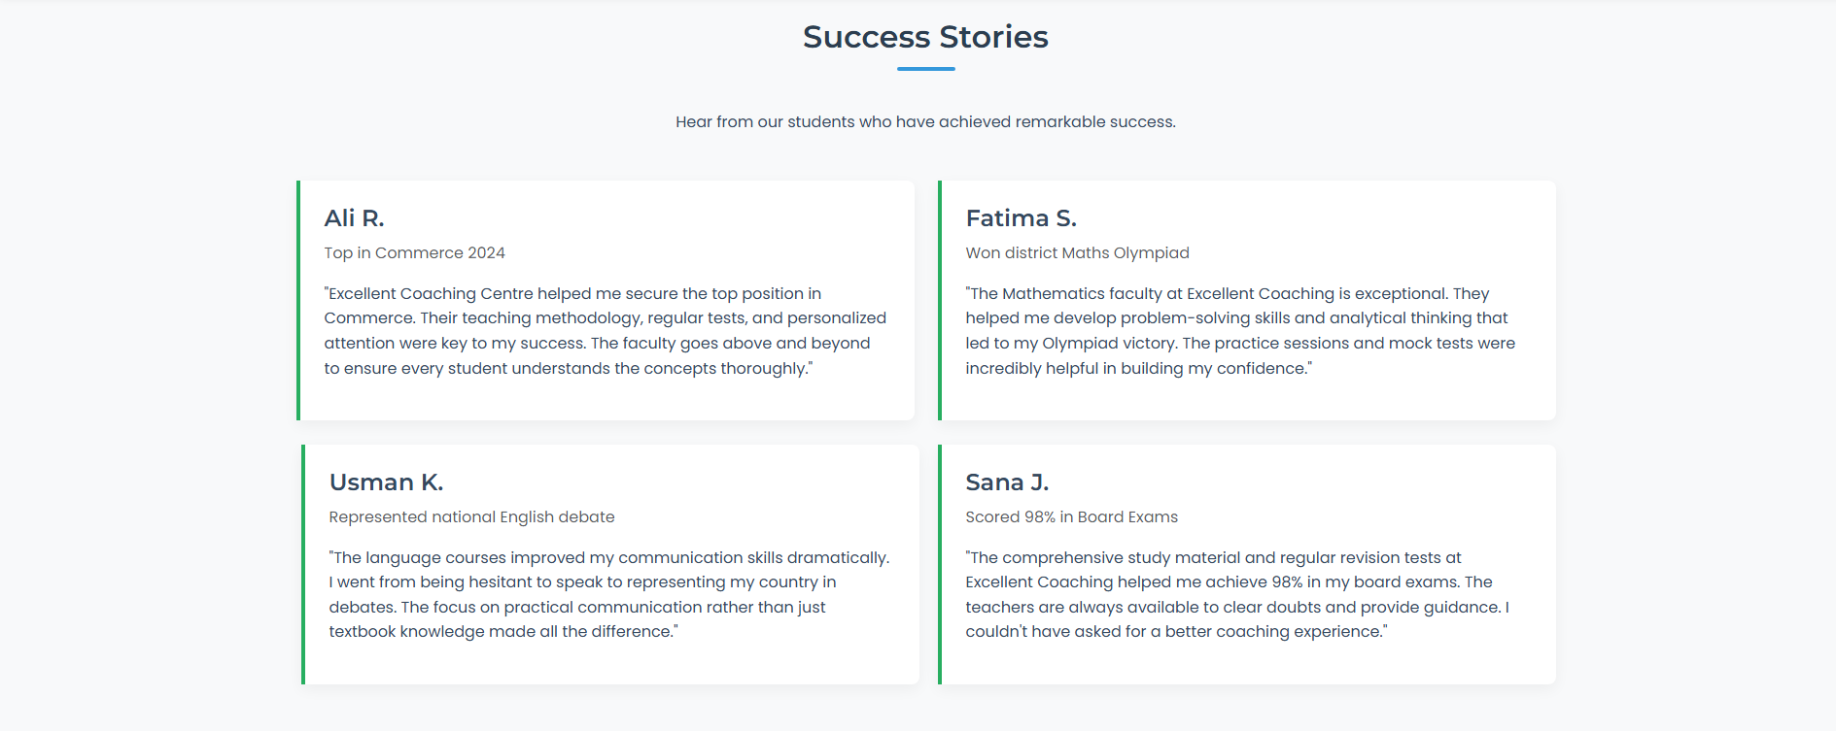  
  
**OUR BRANCHES:**  
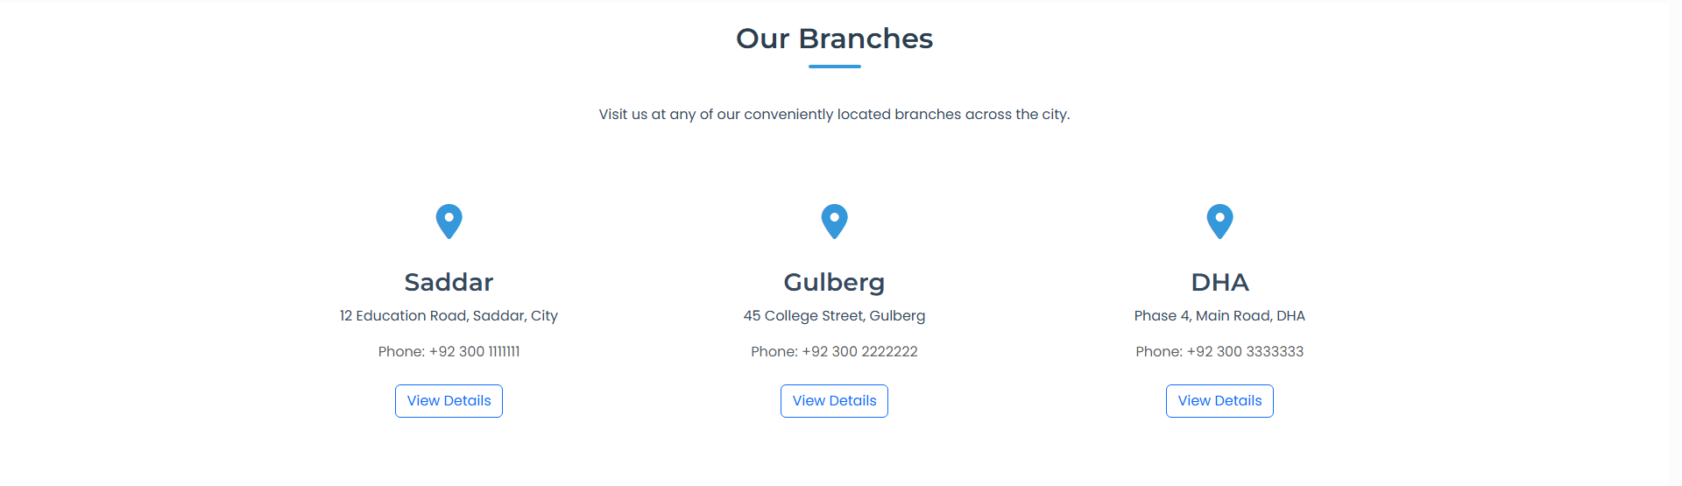

**CONTACT US:**  
  
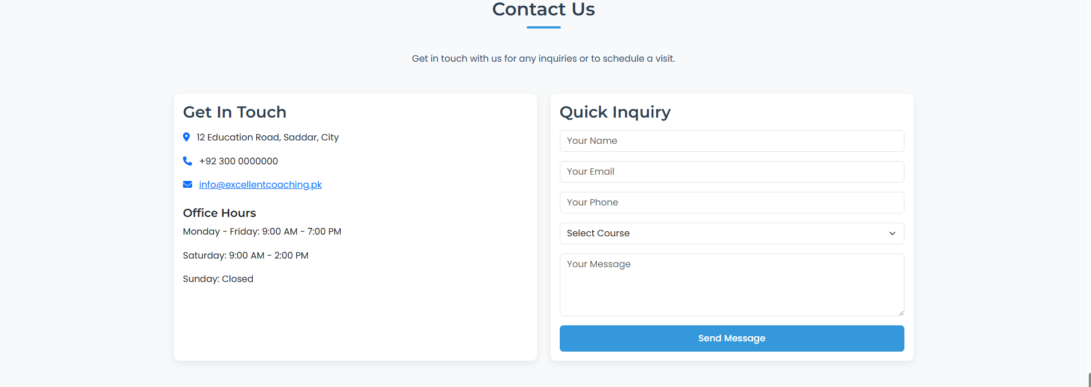  
**SING UP:**  
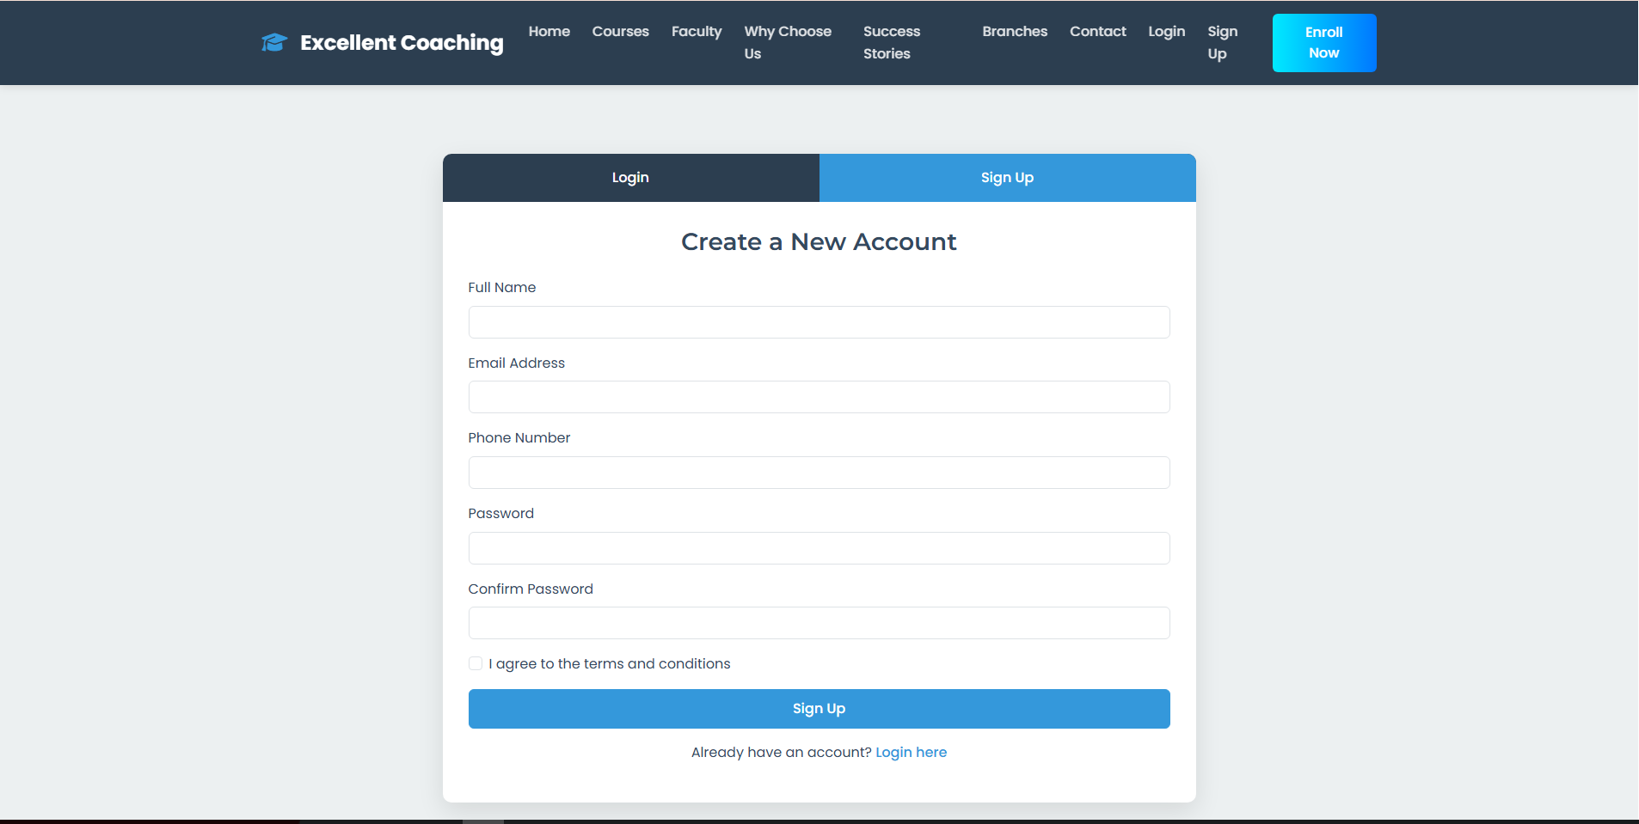

**LOGIN:**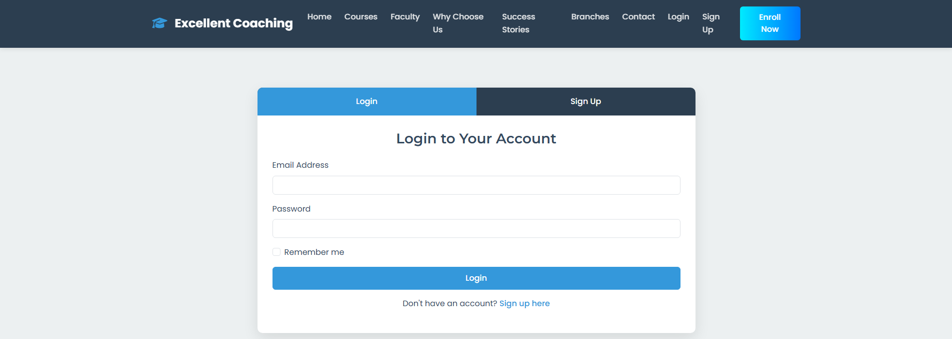

**FOOTER:**  
